Regarding laziness

Take the female detective-series I love to watch. The detective leaves work after a whole day of driven, energetic detecting. Next thing you know they’re in the pool doing laps, after which they drink a chilled glass of white, following which they just have to go back to work. Alternatively, they leave work only after everybody else have left and the lights are out, then go to a bar where they still have the energy to pick up some random guy. Fast forward, they wake up hung-over in a moldy bed, take one look at their miserable face in the mirror before heading straight back to excellent detecting. You don’t catch them staring into empty space wondering that the hell the point is. They don’t get sidetracked into unproductively reading news on the internet, suddenly finding themselves absorbed in an alleged feud between Kate and Meghan, after which they are too unfocused to work and go home and would have loved to spend the rest of the day on the couch. Had they not been blessed with kids disabling any such indulgence. The female detectives work obsessively as if they cannot help it. I would love to be that driven.
But I’m not that driven and never have been. I have met people who get up in the morning to write a couple of hours before their kids get up. Or they go for a run. Such things are utterly beyond me. I desperately need the sleep, plus if I set the alarm everyone will wake up. Because of this and my need to collapse on the couch most nights, I have come to see myself as lazy. Does this mean I will never really do anything important? It is not that I am especially unproductive. It is just that if left to my own devises, I will oscillate between short spurts of intense action followed by longer periods inclined to do nothing at all. Of course, between kids and work, that is not really an option, but what I’m saying is, I’d do it if I could. But what does it actually mean to be lazy? Who gets to decide? I mean; who should I even ask to find out? Is lazy something one is or something one does? Is it productive? And if yes, of what? Chaos? Mess? Calm?

You can only delay so much gratification
My first inclination is to call up some colleague from the Department of Psychology but I realize no one is in their office due to corona-lockdown. Instead, I opt for the ‘light’ version of googling ‘the function of laziness’. This maneuver sends me towards an online article in Psychology Today called The Psychology of Laziness by Neel Burton, psychiatrist and philosopher, which should do it. In the article, Burton defines a lazy person as someone who “is able to carry out some activity that he ought to carry out, but is disinclined to do so because of the effort involved” (Burton 2014).
Ouch.
I know I ought to have looked up the research in the relevant databases, I chose google, a shortcut. Instant gratification trumped effort. Guilty.
According to the article, which has already proven useful, laziness of the kind defined above, is theorized as a lack of ability in a person to disregard instant gratification in the pursuit of long-term goals (Burton 2014). What I read between the lines is the old marshmallow-test all over again, according to which a child’s ability to not eat a marshmallow placed in from of them on the promise of getting another one a couple of painful minutes later becomes pregnant with said child’s future success in life. From this perspective, laziness is fundamentally all about the ability to delay gratification and is heavily laden with moral in the genre where abstinence is better than indulgence.
I talked recently to a colleague about my lack of patience with academia. She went on to lecture me, kindly and totally within acceptable limits, on the value of delayed gratification. For a moment there, I accepted that I was bad at it, but then I remembered: HEY! I have two kids aged eight and three; I have been delaying gratification in certain key areas of my life for nine years now. I would love to a) wake up in the morning when I felt like I was done sleeping and not have to immediately serve my people, or b) come home from work when I wanted to, throw myself on the couch with a good book and not give a toss about dinner. I have noticed that in periods where I have to do a lot of things I don't derive any particularly satisfaction from such as preparing classes until late at night, correcting student exam papers, or attending zoom meetings, I get more prone to do other stuff that satisfy me on the very short term. I guess I am only able to delay so much gratification. After all, one cannot be expected to postpone gratification in all aspects of life can one? In any case, laziness of this sort would be a response to delaying too much gratification in other aspects of life.

One reason or another
This echoes a later theory of laziness presented further down in the article by Burton. We learn here that “many people are not intrinsically lazy, but are lazy because they have not found what they want to do, or because, for one reason or another, they are not doing it” (Burton 2014). Here then, laziness is not the result of some deficiency in a person predictable since early childhood, but might be caused by the circumstance that for one reason or another, people are not doing what they want. I like this better. It raises a question rather than offer an explanation.
Many an early afternoon, I plan to work after I have put the kids to bed, but once I get there I am totally drained of all creative focus. I find there are so many things preventing me from doing what I feel I could do, if only I could get my act together. Kids is the over-arching number one reason. But it is not the only reason, and sometimes I wonder if it they are just a very convenient excuse: A lot of people with kids does so much more than me.
Here’s the thing: I’ve lately come to think of myself as an absorber. Of people, of books, of tensions, of bits of pieces of trivia, of problems and ideas. It is such a physical release for me when I finally get around to get some of it out – through writing or drawing or making some physical object. But mostly, because I never seem to get to the part where I create, it just builds up until all I seem able to do is check my email or the news – which off course just adds to the initial problem. It can get to a point where it feels quite claustrophobic or even further to a point where I lose any sense of self and I feel dissolved into pure information. Whatever it is, it is not a healthy state of mind or body.
What usually happens at this point is I begin to randomly complain about the mess our home has yet again become. And this is where Nick usually asks me to go shopping for the evening meal which immediately brings me to a point of white hot fury because how can he not, after all these years, know that the WORST thing to ask me is to go shopping. I hate shopping. But I think mainly he just wants me out of the house thinking it would be good for me and the annoying part is he is most often right. Not that it solves the fundamental problem but it does at least offer a break from soaking up information during which I can recuperate some sense of proportion.
Shopping for the evening meal does not in my book count as doing. It is a repetitive task like washing the clothes or hoovering or picking up stuff from the floor. It is not something, which will ever occasion you to stop and marvel or just think ‘I did that’. And mostly, these tasks or the work-related pendants – are what comes between me and what I consider ‘real’ or ‘worthy’ doing. Because of their ever present-ness, I can’t just do them once and for all. They are always there, tempting me away from what I feel is my real purpose. Punishing me immediately if I don’t tend to their need for constant attention: No food in the fridge; no clean knickers; rice under my sock, the table sticky with honey, and then there’s the egg mush fused to plates and cutlery and no amount of dishwashing will get it off, you’ll need to scratch it off with a nail.
Suddenly, I am struck by the thought that while the rest of my household is immersed in perpetual ‘doing’ resulting in manifestations of their thoughts and shit loads of mess, I have resorted to the role of enabler, mitigator, and annihilator of collateral damage. How did it come to this? How do I turn the tides?

Imagination and doing
Based on my own experience I immediately have to distinguish between two modes of imagining. If I imagine something I desire, I tend to imagine in very broad brushstrokes, whereas in the opposite case I imagine in great detail and quite possibly a great deal closer to truth. For instance: Nick and I drive by a dilapidated farm in the middle of nowhere. The thing is; the more run down and disorderly the place is, the more it touches some deep, warm place in Nick and he immediately starts to imagine how happy we would be if we lived in such as place. Meanwhile, what I imagine is the smell of moldy wallpaper. In my minds eye, I can see the missing paint everywhere. I know the feeling of walking on the dirty, impossible-to-hoover-due-to-cracked-linoleum-covering-the- raw-concrete floors. Most likely, the washing will never get really dry leaving the bedlinen with a permanently musty smell. I know for a fact how much we will argue about stupid things that needs fixing. We will need to drive the kids everywhere because there is no public transport and their friends will live many kilometers away and we will never have any food in the fridge because we are last-minute-at-least-once-a-day shoppers and out here there is nothing. I really know how to kill his moment, so I try to keep my mouth shut.
On the other hand, I have a tendency to be suddenly overcome with travel plans. Wouldn’t it be great if we all went to Scotland and lived in a small village, possibly by the Sea, for four months? I can just picture the family unity and outdoorsy life we would lead and how my research would thrive and the kids would have an adventure. Nick: No so much. He has already foreseen how he will get grumpy not really having a lot to do and how his daughter who currently sports a tremendously high-pitched English accent will be bullied at school because the Scots and the English have unsettled business not helped by Brexit. Plus if you’re a man in the UK and you look at another man in one of multiple wrong ways you are likely to get beaten up. So we don’t go and we don’t buy the run down farm and we certainly save ourselves a lot of grievance, but fact remains: there is a lot of stuff that we don’t do.
Maybe the trick is to never stop and think at all. It is certainly a tried and tested path to success when it comes to swallowing big pills and getting one’s body into the Sea. In fact, to go back to the beginning, there is almost immediate reward in not thinking about things but just doing them. Maybe it is not the instant gratification part that constitutes the problematic part of lazy, maybe it is the thinking part. To go back to the beginning of Burton’s article, if ‘lazy’ is a person who “is able to carry out some activity that he ought to carry out, but is disinclined to do so because of the effort involved” then lazy is a rational outcome of assessing a given task and the work involved in carrying it out and not finding it is worth it. From this perspective laziness might easily be confused with due diligence and cost-benefit calculations.
I only mention this because when you read about very creative and productive people what strikes me most is that they do not seem to have any inclination towards that detailed imagining of future hardship. The antidote to lazy then is just ploving ahead with no thought for the consequences or bill to pay further down the road. It is emptying your LEGO box in the middle of the floor not caring that you will have to pick it up again. It is starting an immense building project not caring if you have the time or money to conclude it. It is getting out all the PlayDoe five minutes before bedtime. It is in fact dispensing with the long-term perspective in the pursuit of immediately going about manifesting your thoughts.

Manifestation of thought
# 1
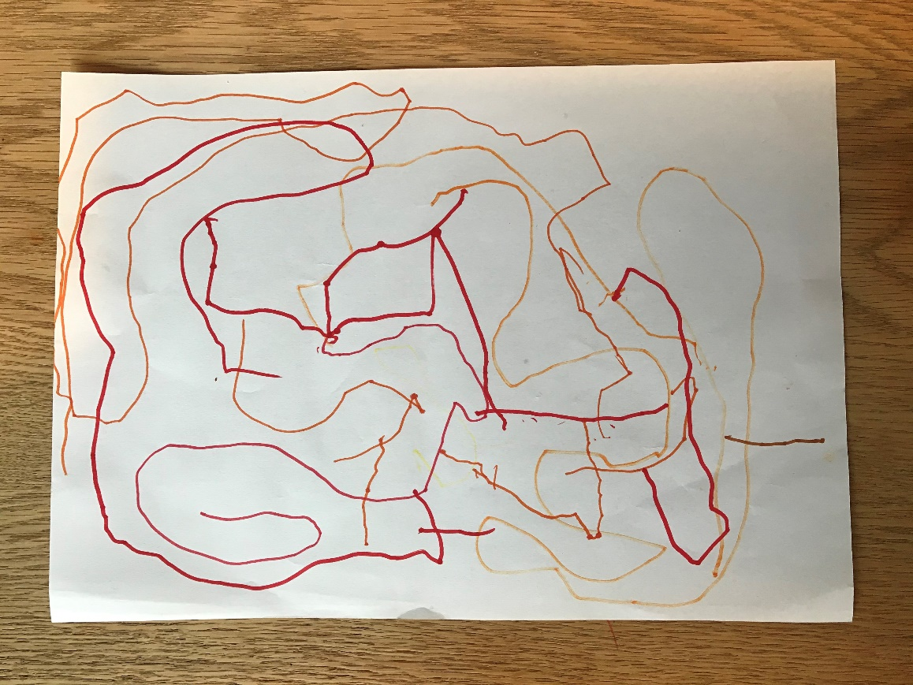
#2
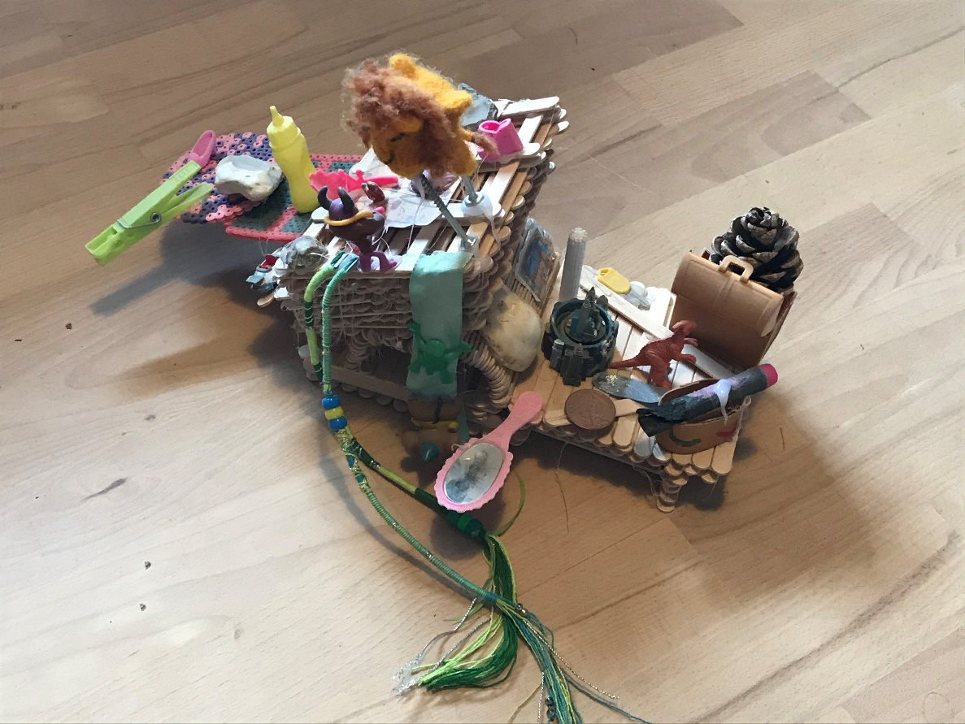
#3

#4
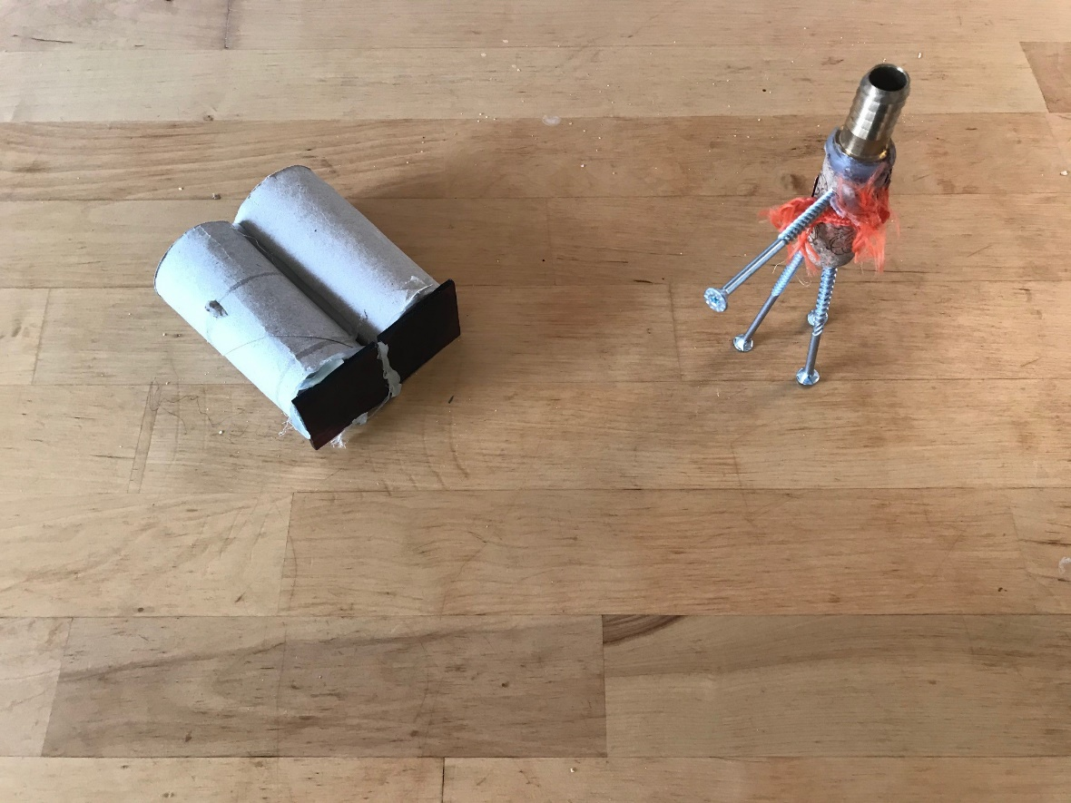

#5
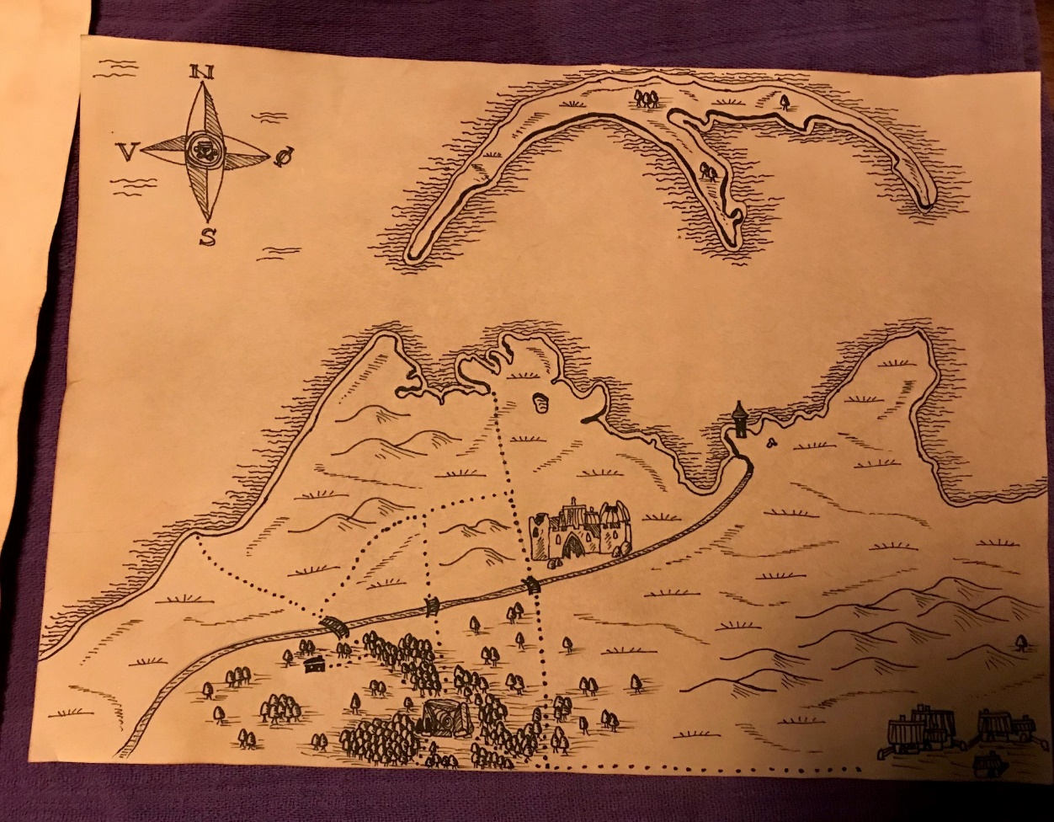

Burton, Neel. 2014. The Psychology of Laziness. Psychology Today. 25 October 2014. https://www.psychologytoday.com/us/blog/hide-and-seek/201410/the-psychology-laziness, accessed January 27 2021.

